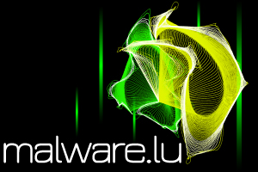

malware.lu CERT
  - Incident reporting form

Type | Standard
Sequence number | C005
Version | 1.0
State | Final
Document owner | C. Harpes
Date | 13/03/2017
Classification | Public

Contact information
First Name
Last Name
Email Address (Required)
Organization Name
Telephone number
What type of follow-up action are you requesting at this time? | Please select
From what time zone are you making this report? | Please select
Incident identification
What is the impact to the targeted organization? | Please select
Describe the current status or resolution of this incident. | Please select
Was critical infrastructure (or system) impacted by this incident? | Please select
What is the category of the incident? | Please select
What is the approx. time the incident started? (local time) | Please select | 01:00
When was this incident detected? (local time) | Please select | 01:00
Incident details
Please provide a short description of the incident and impact.
Which systems are impacted by this incident (how many, name(s), classification(s), location(s) and are they national or local systems)
(Leave blank if unknown)
Was the data involved in this incident encrypted? | Please select
What was the primary method used to identify the incident? | Please select
Additional information (free text, example: actions done)

The following form has been developed to ease gathering incident information. If you believe you have been involved in an incident, please complete - as much as possible - the following form, and send it to cert@malware.lu (public KeyID: 0xC8F71EEB )
Alternatively, you may also call us at +352 26 176 212

